Name : d.madan kumar

Reg no : 192111559

Course Code : CSA0726

**COMPUTER NETWORKS LAB EXPERMIENTS**

**DAY-3**

17.IOT Devices in Networking Using Cisco Packet Tracer

**AIM :** to create IOT Devices in Networking Using Cisco Packet Tracer

step1:-first take home gateway

step2:-link that router with celling fan and lamp and tablet

step3:-connect that celling fan and lamp with the tablet

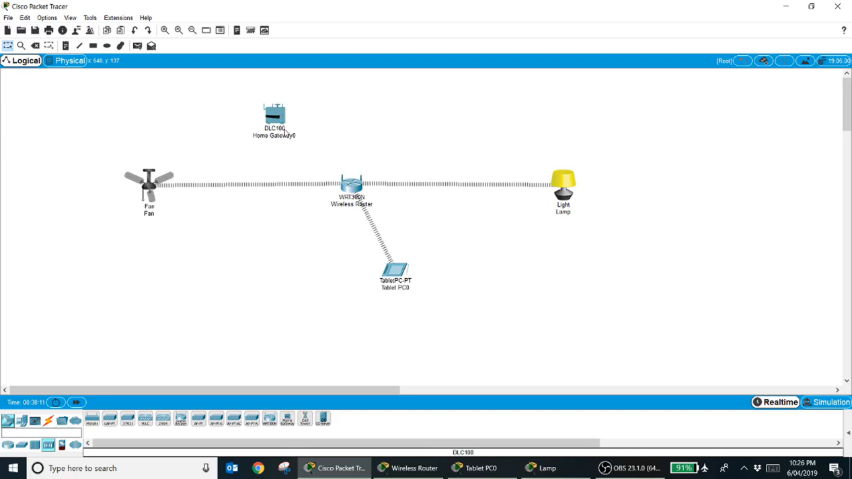

step4:- after connection celling fan and lamp with connection of tablet Check the connection with the appliances

step5:- if command send correctly you got successfull other wise recheck the connections

Step6:- then the celling fan and lamp with connection of tablet successfully simulated and the appliances are working .

